Utilization Of Testing Tools

|  |  |
| --- | --- |
| Date | 18.November.2022 |
| Team ID | PNT2022TMID46949 |
| Project Name | Classification Of Arrhythmia By Using Deep Learning With 2-D ECG Spectral image Representation |
| Maximum mark | 2 Marks |

**A broad range of products to satisfy all testing needs. 100% scalable and reliable. Learn how to automate testing and deliver new releases faster than ever before. Test all digital services. Download leaflet. Test in any location. Flexible alerting. Immediate results. Active Testing.**

**A broad range of products to satisfy all testing needs. 100% scalable and reliable. Learn how to automate testing and deliver new releases faster than ever before. Test all digital services. Download leaflet.**

**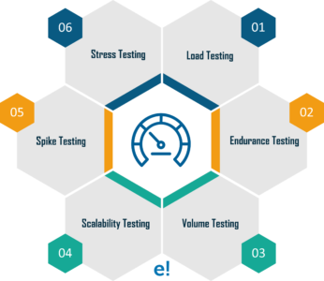  
TestRail is the most actively developed test management tool, so you benefit from regular product updates to make your team more effective.**

**The release of TestRail introduced TestRail FastTrack: a unique three-pane view that is incredibly productive. Add results and jump to tests with a single keystroke. Don’t settle for less!**

**Easily access TestRail with your entire team – hosted on your server or ours. Speed up testing & decrease testing cycle time. Scalable Test Management. Test Plan Templates. Speed Up Testing. Real-Time Insights. Create Test Suites. Traceability Reports.**